FEAR – Advanced scripting tutorial

introduction

Getting Started

Most of the topics that you’ll find in this series of tutorials have their basis in the default WorldEdit manual which you can find in WorldEdit itself by clicking the Help section in WorldEdit and then clicking “Topics.”

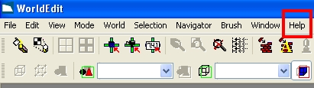

Once you’ve clicked Topics, you’ll want to expand the Command Reference section of the help file and then browse to Command Architecture. You’ll find the correct syntax for all of the commands and operators you’ll need to set up more advanced scripting events in this section. It is essential reading for any Level Designer.

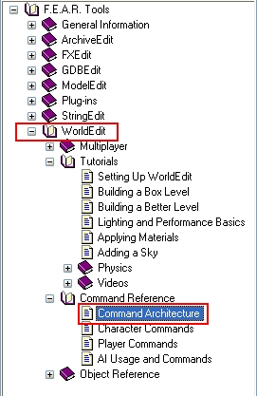

Uses of Scripting

There are a multitude of scripted events that can be found throughout F.E.A.R and XP 1 in all of the released levels. In terms of complexity, they range from very simple “push the button to open the door” type events to heavily orchestrated cut scene events involving specialized animations and precisely timed dialogue sequences. Of course, you’re only as limited as your imagination in terms of the ways you can use the scripting system in WorldEdit.

Examples of Advanced Scripting

A great example of a more advanced script element being used to good effect is the prefab “Container_Waste” in the HospitalXP folder. This prefab contains a piece of script that randomizes whether or not you will receive a SloMo recharger when you destroy it. The script is set so that you only get the powerup 25% of the time. This prefab is a good example of how to make some of the game’s less important elements seem less linear and more conducive to repeated playthroughs. Let’s take a look at how the prefab is setup. Open the “Container_Waste” prefab world and expand the node tree so that all the elements of it are visible.

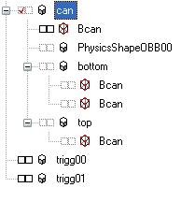

- Select the WorldModel can
- Open the DamageProperties command window
- Open the DamagePercentCommand command window

Within this window we’ll see the exact script for how the main script executes the commands to destroy the model, spawn in broken pieces of it, and decide whether or not it wants to spawn a power up for the player to use. Although the script was not commented out within the actual prefab world, I’ve gone ahead and commented it out for you now so you can gain a better understanding of how to set up your own advanced script events within a WorldModel.

Container_Waste setup

msg #.can REMOVE; / Removes the container.

msg #.bottom (HIDDEN 0); / Displays the bottom and
msg #.top (HIDDEN 0); / top pieces of the container

msg #.bottom (RIDIGIDBODY 1); / Sets the bottom and top
msg #.top (RIGIDBODY 1); / pieces to become physics
/ enabled.

msg #.PFX00 ON; / Particle FX that occur
msg #.PFX01 ON; / when the container
msg #.PFX02 ON; / is destroyed.
msg #.PFX03 ON;

RandWeight 0.25 (msg #.trigg00 ON) (msg #.trigg01 ON);

/ Says that the “(msg #.trigg00 ON)” command is 75% less likely to occur than the “(msg #.trigg00)” command. Only one of them will actually execute during runtime.

/ Trigg00 and Trigg01 are the triggers that spawn in the power up and remove it from the world, respectively.

This script runs when the Container_Waste prefab is damaged. The script is in place to swap out the solid unbroken version with a new broken version, as well as giving the player a 25% chance of finding a power up inside of it.

The overall effect of the script adds a nice touch to the balance and realism of the game. Obviously not every hazardous waste disposal prefab would have needles in it, and this is a much simpler way to represent that than making two separate models.

Loop, LoopId, and IF/When/then commands

At the moment, the uses of the Loop, LoopID, and If/Then commands are fairly limited in the sense that they don’t generally provide any kind of versatility over the more basic scripting functions in WorldEdit. However they do work as you might expect them to if you’re familiar with any sort of scripting or programming logic. Here is an example from the tutorial world “Conditional” where you can increment a variable within a loop to change the color values of a light. Select the trigger in the room and open up the command window.

Script Example From A01-TR-Trigger01

int xyz 0; / Sets the initial value of xyz to be 0

ShowVar xyz 1; / Shows us the current value of xyz in the
console

loopid x1 0.01 0.02 (add xyz 1); / ->

/ An infinite loop that causes xyz to add 1 to its current value every hundredth of a second

when (xyz == 90) then (msg A01-LT-Main-01 (COLOR 90 90 90));
when (xyz == 150) then (msg A01-LT-Main-01 (COLOR 150 150 150));
when (xyz == 200) then (msg A01-LT-Main-01 (COLOR 200 200 200));
when (xyz == 250) then (msg A01-LT-Main-01 (COLOR 250 250 250));

/ Tells the LightPoint A01-LT-Main-01 to change its color when xyz reaches a certain value in the loop.

when (xyz == 255) then (abort x1);

/ Aborts the loop when the variable xyz reaches 255

Explanation of the above example

While the above example might not be the most useful example of how to employ the usage of conditional loops, it certainly gives you an idea of the ways you can interface with existing objects in the confines of the loop.

